***2nd Semester “CCL” Final Exam***

## *Ministry of high education and scientific research*

# *University Abbes Laghrour Khenchela*

## *Departement of English literature*

***Group : “04” “G4”, 1st year***

***First Name : Anis Abderraouf First Name : Amina***

***Family Name : Merah Family Name : Lalaouna***

***Teacher : Dr.Fayçal saoudi***

# *Research assignment*

# *” 2nd semester ‘ccl’ final exam”*

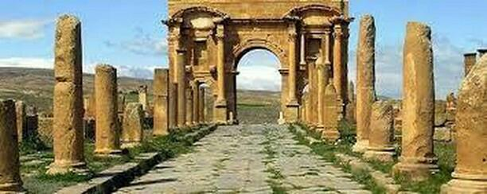

# *“Greek Mythology &Roman mythology”*

# *Introduction* :

When we were young we heard a lot of things about Greek and Romans Empires; no matter how real or fake they were, cause we never took them for granted and most of the time we concerned them as historical legends. Our lives are intertwined with the stories and knowledge of the Greeks, but the Romans are almost never mentioned. Greece and Rome are two well known empires for two great civilizations throughout history. Decidedly, there’d be several sayings about them; however, true or false their entirety, we overwhelmingly took them as legends more than facts mostly their beliefs and religion which we attributed them to mythology. The coming lines will protrude the major similarities and differences between the Greek and Roman religions, the major contributions of the Romans to science and politics, and finally, the full story of the conflict/war between Syphax & Massinissa and its effect on Numidia.

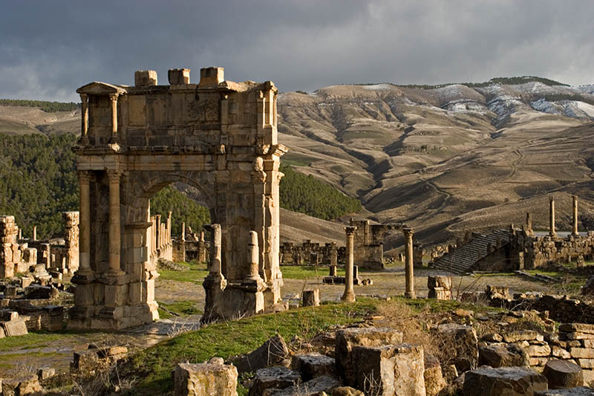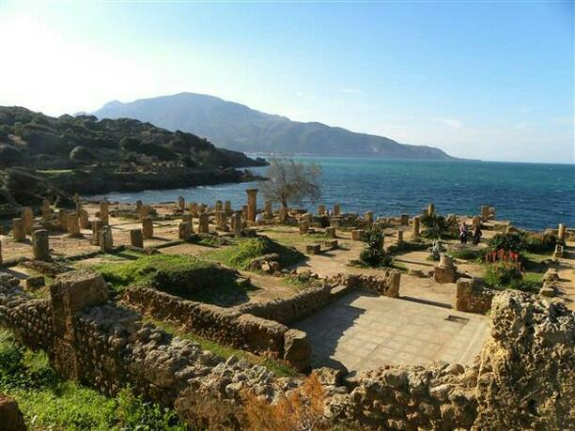

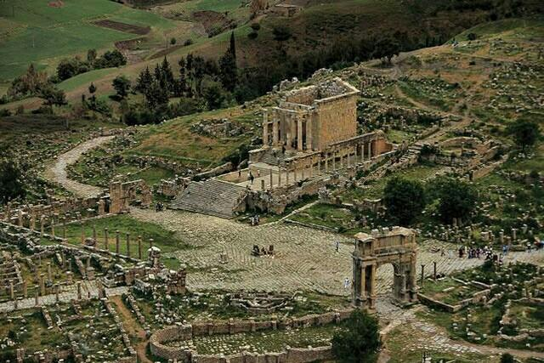

# *Greek and Roman Beliefs:*

Besides history, mythology has always been a guilty pleasure for us. Greek mythology predates Roman mythology by about 700 to one thousand years ; As a function of popularity, Roman mythos isn’t nearly as popular as its Greek counterpart. Since the Romans were more preoccupied with empire building and Caesar killing than their work with the oral traditions; But, they did name the planets after their deities which is nice. Romans borrowed heavily from the Greek pantheons ”group of gods”, and also appropriated many of their homegrown deity’s into Greek equivalents. The Italian peninsula had been in contact with the Greeks for centuries and Greek colonies were spread throughout the Mediterranean so this was somewhat inevitable. To get some of the bigger famous gods out of the way, the Roman pantheon corresponded mostly with a third Greek dynasty called Olympians. Before we move to Olympians we have to talk about the first periods that concerned as the beginning of their mythologies , which are Primordial & Titans. Let’s start by Primordial, which were the Gods of gods. According of their beliefs, they have thought that at the first ages happened a Keyas on the universe and from that Keyass came out” Gaia” who were the Goddess of the earth (some historians said that she was the earth its self and the mother of all the lives). Also, from the Keyas came out “Turtres”( God of the abyss), “Irebiss”( God of the dark, some people said it was the darkness its self), “Neex”(God of The night), and the last one “Irrus”(The youngest one on the Primordial and he’s the God of Love, in fact he was the unique one who didn’t get married. Gaia, who concerned to be the earth, was very Fertile , she even gave a birth to Uranus; who concerned to be the god of the sky or the sky its self; when no one touched her. Then, He married her mother “Gaia” and had kids from her, but their kids were Giant(Half human and half animal), Cyclupeses, and Titans when Uranus got mad and angry cause of that. He took most of his kids and thrown them on “Turtres” and imprison them there. The others who didn’t imprison them called Titans, Chronus were one of them and he didn’t like what his father did to his siblings. Chronos went to Gaia , who didn’t like too what her husband did, and made a weapon for him which he killed his father ’Uranus” by and free his siblings that his did imprison, from here Titans Era started. Chronos became the king of Titans cause of what he did , then he imprisoned he’s siblings again on the turtres expect the Titans and Meliae ( historian said is the tree that all humans came from).Later, Chronos wanted to relax so he got married with Rhea (who were a titan too and his big sister too) and had kids with her named Demeter, goddess of crops; Hestia, goddess of magic and witchcrafts; Hera, sister of Zeus and his wife at the same time , goddess of culture, marriage, civilisation; Poseidon, God of seas, he’s the brother of Zeus; Hades, God of the underworld; Zeus, (means ‘bright’ or ‘sky’) , he’s the king of Gods or God of lightning. Chronos were afraid of his sons; he had fears if they’ll do to him what did he do to his dad. So he started eating them one by one, cause he thought it was the unique solution for him to save himself. He continued eating his sons till the last one ”Zeus”, Rhea changed Zeus by some stones when Chronus ate them without think. She hided Zeus till he grown up and defeated his dad and saved took off his siblings again from the stomach of his dad and saved them. After that, Zeus unleashed the Giants that Chronos imprisoned on turters; they wanted to thank him for what he did so they made gifts for him and his two brothers, thorn for Poseidon, helmet head for disappearance for Hades, and an arrow made of lightning bolt for Zeus. Then, Zeus with the Olympians and new gods defeated his dad Chronos and the titans on the Olympic mountain and became the god of the sky and lightning bolts and the king of gods and Olympians on Olympic mountain. He sent the Giants to be guardians on turters for the titans ,as his first action. After that, he started giving everyone their missions. So, Hades, became the god of the underworld and the king of Abyss; Poseidon, became god of seas and oceans; Demeter, became the goddess of aging; Hera, became the goddess of marriage; Apollo, became god of sun and music, he’s the son of zeus and his mother called “Leto” , she was a titan; Artemis, became the goddess of hunting, wilderness, childbirth, and plague. She’s the twin and sister of Apollo; Aphrodite, became goddess of Love and beauty, she was the daughter of Zeus and Dion; Athena, became the goddess of wisdom; Hephaestus, son of Zeus and Hera and was a craft man , he became the god of fire and Husband of Aphrodite ,who were obliged to marry him. They concerned him to be messenger of gods; Ares, son of Zeus and Hera and Brother of Hephaestus, he was hated but he became god of war; Dyonisaus, became god of vines and parties; Hermes, became god of intellegance. When it comes to Romans mythology, we notice that are almost have the same beliefs. However, in Romans mythology Zeus, Hera, and Athena became Jupiter, Juno, and Minerva; respectively the three patron gods of Rome. Ares, Aphrodite, and Poseidon became Mars, Venus, and Neptune; Hermes with his cool winged shoes became Mercury, the god of communication, transport, and commerce. Uranus and Gaia ,who through their marriage, bore Saturn one of the oldest and most famous gods of Roman mythology. Saturn was hugely important to the Romans as he reigned the supreme deity and father of Jupiter , corresponding to his Greek equivalent Chronos. The Age of Latin dominance over Italy is said to be attributed to him and his name lives on the planet Saturn and 6th day of the week Saturday. The winter solstice festival became dedicated to him in the month of December as Saturnalias or Saturn Festival and Christmas was later moved to December 25th to coincide with it illustrating just how important it was to the Romans. Hades the Greek god of the underworld would become Pluto; Hephaestus the Greek god of fire became Vulcano, where the modern word volcano comes from.The odd one out was Apollo who seems to have blended over time with some other deities; Classic Roman mythology places him with Greek Apollo the son of Jupiter, but Apollo was also worshipped for many other things. Hercules was adopted from the Greek hero Heracles the son of Zeus and a mortal women, was an immensely influential character in Roman times and his stories feature heavily. Concerning the afterlife, in Greek mythology the afterlife does not doesn’t hold much importance. In fact, gods and mortals are regularly snatched from the afterlife and brought into the present, showing no concern for the afterlife. The Greek prespective is much more concerned with the physical life on earth as opposed to the afterlife. However, mortals are remembered and rewarded for their good deeds honor contradiction, the Romans did good deeds to secure their place in the head within this religion the gods control the outcome of everthing. The priests and gods Temples convey the gods wishes; and within the rest of the humans, the men were the ones who did all the religious things like : Visit temples, give tribute, the women not allowed to go out in public too much. For Concluding, both Greek and Roman religions were deeply embedded in their lives. We can say that both them have differences as well as they have many similarities, but what really makes the difference between them is The unity of social duties and religious belief which paganism provided was severed by the institution of a religion which removed the gods from the earth and human society and proclaimed only one God who ruled from the heavens. This new god, unlike the gods of old, had no special interest in Rome - he was the god of all people - and this distanced the religion of Rome from the state of Rome.

# *Romans Contributions:*

Legacy, a precious word with wonderful meaning, and what make it more valuable is the physical meaning. When we say a legacy, what I mean is what Rome has left behind for the future generations to use and to learn from in Architecture, Law, Engineering, Language, and Religion. First of all on architecture, the government built public works- structures for public use; they also built public baths, temples, bridges, formus, Statues paintings art, decorated buildings, and marketplaces. Also, concerning engineering, Romans invented ***concrete***, which was stronger and easier to use than stone and designed huge ***arches*** and ***domes*** with it. Concrete was used to build more than 50,000 miles of roads; the network helped unify the empire. In addition, concerning the Water Supplies, Public fountains supplied clean water to citizens; sewer systems carried away wastewater; public baths were all to enjoy; aqueducts carried water from miles away. When it comes to Roman Law and Language, In 451 B.C the leaders of the republic wrote the Twelve Tables when they were posted for all to see. However in Law and Citizenship, Although the Twelve Tables changed some ideas stayed constant, Good government based on rule of law; All citizens have equal rights under the law; Multicultural- consisting of many different cultures and religions. On the other hand, Influence of Roman law was limited to Roman citizens. Principles of the Roman Republic, such as equal justice under the law, rules for foreigners ( International Law), are part of our government; The United States and many European and Latin nations have been influenced by Roman law. As the rest, left their legacy on language too as well .The Romance languages ( Spanish, Italian, French …ect) are based on Latin, the language of the Romans; Our alphabet is based on the Roman alphabet. Finally, they took care of Christian Religion as well. Christianity, based on the teachings of the Jewish prophet Jesus and Roman officials feared a Jewish rebellion and executed him; Early Christians were persecuted, but in the 300’s AD., Emperor Constantine made it the official religion of the Empire. For Concluding, we should be thankful with Romans cause of their Contributions that left for us on Architecture ( monuments, forums, public baths); Law( rule of law, legal, systems); Engineering ( concrete, arches, domes, aqueducts); language( Romance languages) ; religion( Christianity). They have made a big difference on humans life.

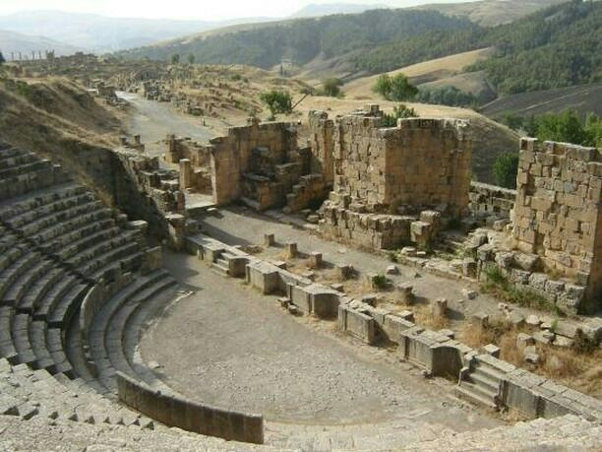

# *Syphax VS Massinissa ( Full Story):*

During 300 BCE, the Berber tribes joined in the North of Africa in from of kingdoms. Its territory extended from the desert of Libya in the east, to Gibraltar in the west, and from the Mediterranean in the north to the Sahara desert in the south. These kingdoms were represented by Gitul, Garmant, Moors, Masal, and Masil. They lived in the form of tribal federations based on the family; Each tribe is ruled by a chief or king from a family of prestige, influence, and wisdom, usually the largest. This organization also included a tribal council made up of its elders, which in turn met every three months at the beginning of each chapter. Massicilia was one of the most prominent Numidian kingdoms, and it was also known as Western Numidia. In addition, it grew up on the banks of the Tafna valley in western Algeria today; Its provinces extended from the Moulwia River in the west, to Sirta in the east, then its borders shrank to the Chlef River. King Syphax led it and made Sega (now Ayn Temushant) its capital. On the other side, East of the Kingdom of Massicilia extended the Kingdom of Massilia; which was the second largest and most powerful of the Numidian kingdoms; was known as Eastern Numidia, and its territories extended from Sirta (present-day Constantine) to Tripoli; and then expanded at the expense of the lands of Massilia until the separation of Oued Chlef between the two kingdoms .Led by Alaglid Gaia and made Cirta his capital,then his son Massinissa replaced him. Later, The Numidian kings and their warriors had a prominent role in all three Punic Wars. It was fought for more than 100 years between 264 BC and 146 BC, and its fire was burning between Rome and Carthage at that time, the two most contested poles over areas of influence in the Mediterranean. Hannibal, commander of the Carthaginian armies, achieved great victories thanks to the Numidian cavalry in his famous campaign against Rome during the Second Punic War between 218 BC and 201 BC, in which Massinissa led the Knights of Numidia and the Carthaginian army in the Battle of Hispania (now Spain) when he even didn't close 20 years old that he achieved a significant victory. While Massinissa was in Spain his father Gaia died, and his old uncle ascended the throne. Carthage worked with King Syphax's complicity in taking the kingdom of Massinissa. Syphax seized the opportunity of the absence of Massinissa and the new alliance to annex Cirta to his kingdom and make it his second capital, when even Azurbal king of Carthage gave him his daughter Sophonism to marry her, the fiancée of Massinissa. In the autumn of 206 BC, Massinissa returned with his army to Numidia after informing him of what had happened in order to regain his right to the Masilian throne, across the Strait of Gibraltar (known then as the Pillars of Hercules) and entered the Moorish kingdom where its king Gaba received him and placed under his command 4000 soldiers, received him in Sirta borders 500 warrior of the kingdom, then his knights and soldiers loyal to his father Gaia joined him. Suddenly, Syphax's army attacked and headed by a senior commanding officer, Bogar Macencia, and seized victory over him. After this incident, it was believed that Massinissa had died, but he sought refuge in Auras, where the Gitul tribes (which had never been exposed to colonialism and completely rejected it, and that Massinissa was in distress), to restore his powers and reorganize his army to take his revenge from his opponents again and restore Numidia From their hands united from the east to the west. In the year 206 BC, both Rome and Carthage sought to win the alliance of the Numidians to end the conflict between them. This year also witnessed the first peace conference between the most prominent leaders and powers in the Mediterranean basin, represented by Ciphon from the Roman side and Syrban from the Carthaginian side, and the conference was held. In Sega (present-day Ain Temucent) under the auspices of Syphax who insisted on reconciliation and spare the region a brutal war.Massinissa was known for his hostility to the Carthaginians and the Romans at the same time, both of which are alien to the Berber countries of Numidia. Sipion insisted on the war, so Syphax allied itself with Carthage, and as for Massinissa, he allied with Rome, and joined his army of 6000 soldiers to the Roman armies, which exceeded the number of its soldiers more than 37 thousand between the infantry and the cavalry. In addition, they attacked the Carthaginians and Syphax at the same time, in what is known as the victories of the Great Plains, in the Algerian-Tunisian borders; that were witnessed in the year 203 BC, and in which all kinds of martial arts, weapons, army units , and elephants were used . As a result, this war were considered the decisive half of the Punic Wars, where victory was an ally of Siphisians and Massinas, while it was the end of the legend of Hannibal , the cheats of Syphax, and the influence of Carthaginian in Numidia.Massinisa regained all territories unified under the banner of Numidia and left Sirta as their guardian; in fact, Serta wasn't the only thing that Massinisa regain, Sofonisme also took back, who was waiting for him and married her.

# *Sources :*

<http://www.perseus.tufts.edu/hopper/text?doc=Perseus:text:1999.04.0104:entry=masinissa-bio-1>

<http://arlt.co.uk/laelius.html>

<https://miltiade.pagesperso-orange.fr/GB/Ancient_North_Africa.htm>

<https://www.nsspress.com/clements_western_2nd_demo/ch1/sec9.htm>

<https://www.otago.ac.nz/library/exhibitions/classical_world/>

<https://www.nationalgeographic.org/article/traces-ancient-rome-modern-world/>

<https://youtu.be/SfddTct6-Ak> <https://youtu.be/m5V-IK1cEtE>

<https://youtu.be/UdMCg_yb8L8> <https://youtu.be/9IXn3xHhkgg>

<https://youtu.be/HbhAuq2ZOaI> <https://youtu.be/T4st05lULMs>

<https://youtu.be/q0aJbKwABMo> <https://youtu.be/GXoEpNjgKzg>

