***Articulatory Phonetics :***

1. 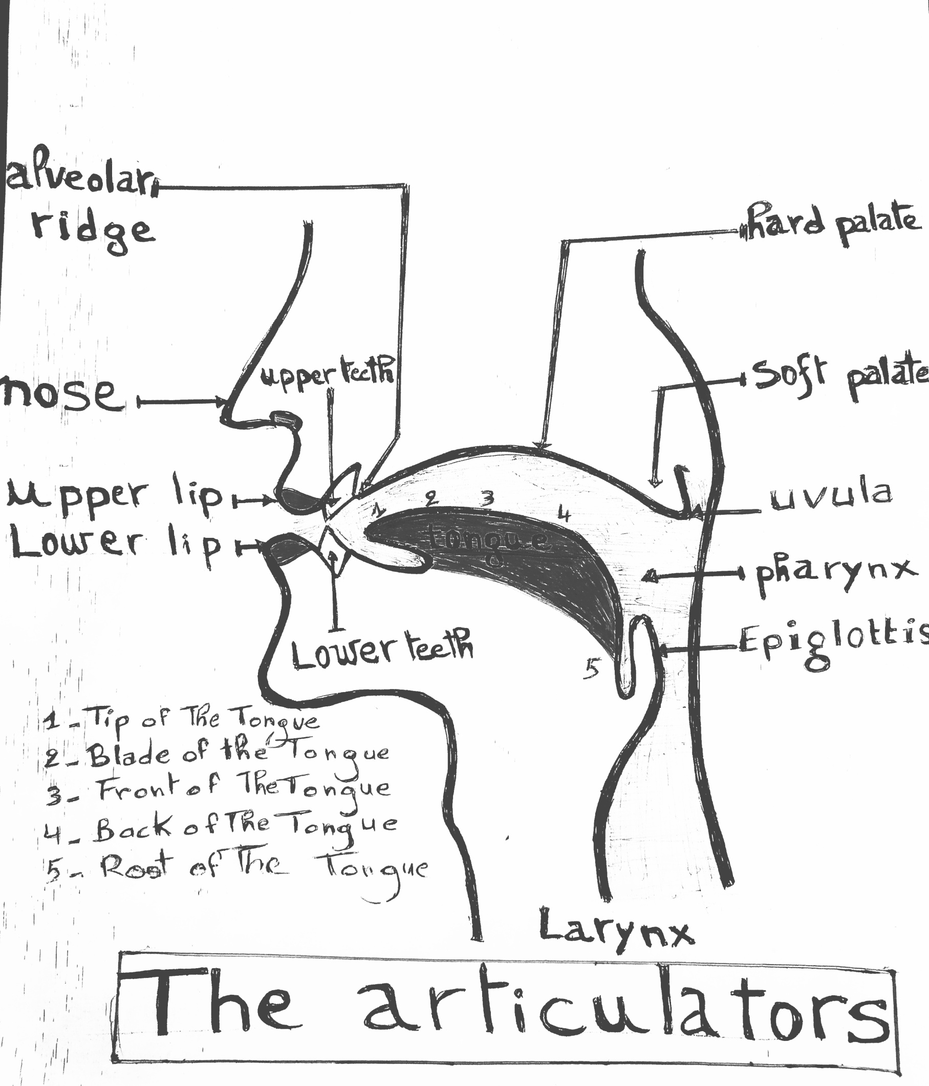***Speech Organs***
   * + ***The tongue : tip,blade,back***
     + ***The teeth***: ***upper/lower teeth***
     + ***The lips :*** ***upper/lower lip***
     + ***Palate :*** ***hard/soft palate***
     + ***Alvelor ridge :***
     + ***Uvula : at the end of the mouth***
     + ***Pharynx:***
     + ***Glottis:***
     + ***Larynx(voice box-Vocal cords):***
     + ***Nasal cavity: Nose+ passage connected to the throat***
2. ***Place of articulation:***
   * + ***Bilabials:*** ***lips pressed+restriction of air***

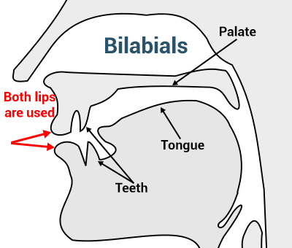

* + - 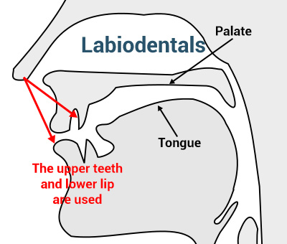***Labiodentals: upper teeth+ lower lip***
    - ***Dentals: tip of the tongue+ upper+lower teeth***

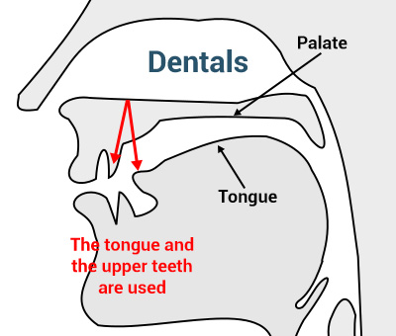

* + - ***Alveolar: tip of the tongue raised to the alveolar ridge***

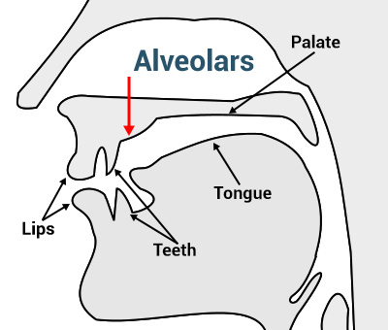

* + - 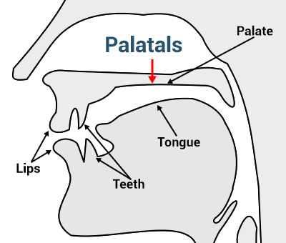***Palatal: back of the tongue that comes into contact with the palate***
    - 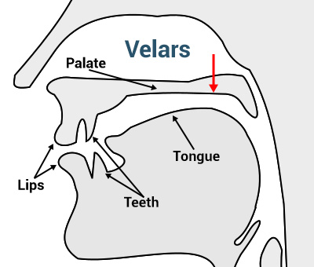***Velar: sounds created by bringing the back of the tongue to the uvula [k]*** ***[ŋ]***  ***example “king”***
    - 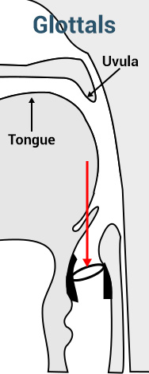***Glottal: sounds The glottis, as much as we might not realize it, is used for the h sound in English; [h]. example: “Hello”***

1. ***Manner of articulation: how sounds are produced? Degrees of air blockage (obstruction)***
   * + ***Plosives(stops): the air is stopped momentarily and released quickly***

**/p/ /b/ /t/ /k/ /g/ /d/**

***Examples:* “back” “tab” “kite”**

* + - ***Fricatives(continuents): no blockage of air, a friction noise/ hissing sounds***

**/f/ /v/** **/θ/** **/ð/** **/s/ /z/ /ʃ/** **/ʒ/**  **/h/**

***Examples:*** “**s**uit” “vi**s**ion” “**h**appy”

* + - ***Affricates: When stop consonants mix with fricative consonants.***

**/tʃ/** – “**ch**eck”

**/dʒ/** – “**j**am” and “ba**dg**e”

* + - ***Nasals: Nasal consonants are created when you completely block air flow through your mouth and let the air pass through your nose.***

**/m/** – “**m**ad” and “cla**m**”

**/n/** – “**n**o” and “ma**n**‘

**/ŋ/**  –  “goi**n**g” and “fu**n**k”

* + - ***Laterals: Air stream escapes from the tongue sides.***

**/l/** – “**l**uck”- place the tip of the tongue at the alveolar ridge

* + - ***Approximants: Approximants are when two articulators come close together but not quite close enough to create air turbulence.***

**/w/** – “**w**et” and “ho**w**ard”

**/j/** – “**y**es” and “ba**y**ou”

**/ɹ/** – “**r**ight” and “**r**oa**r**”

1. ***Voicing:***
   * + ***Voiced sounds:(fortis) production with vibration of vocal cords***
     + ***Voiceless sounds:(lenis) production with the vocal cords apart so the air flows the glottis***

**Example :/f/ /p/ /k/ /θ/** **/s/ /tʃ/**  **/t/**