Oral Expression

**Lesson One**: **It’s Christmas (That Time of Year)**

The Christmas colors:

**Green**

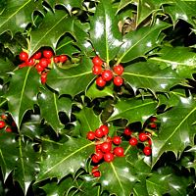

Evergreen plants, like [Holly, Ivy](https://www.whychristmas.com/customs/hollyandivy.shtml) and [Mistletoe](https://www.whychristmas.com/customs/mistletoe.shtml) have been used for thousands of years to decorate and brighten up buildings during the long dark winter. They also reminded people that spring would come and that winter wouldn't last forever!

[**Holly, Ivy**](https://www.whychristmas.com/customs/hollyandivy.shtml)

The prickly leaves represent the crown of thorns that Jesus wore when he was crucified. The berries are the drops of blood that were shed by Jesus because of the thorns.

**Red**



As mentioned above, early uses of red at Christmas were the apples on the paradise tree. They represented the fall of Adam in the plays.

Red is also the color of Holly berries, which is said to represent the blood of Jesus when he died on the cross

**Gold**

Gold is the color of the Sun and light - both very important in the dark winter. And both red and gold are the colors of fire that you need to keep you warm.

Gold was also one of [the presents brought to the baby Jesus by one of the wise men](https://www.whychristmas.com/story/wisemen.shtml) and traditionally it's the color used to show the [star that the wise men followed](https://www.whychristmas.com/customs/star-of-bethlehem.shtml).

**White**

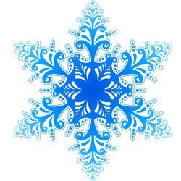

White is often associated with purity and peace in western cultures. The [snow](https://www.whychristmas.com/customs/snow.shtml) of winter is also very white!

White paper wafers were also sometimes used to decorate paradise trees. The wafers represented the bread eaten during Christian Communion or Mass, when Christians remember that Jesus died for them.

Silver is sometimes used instead of (or with) gold. But gold is a 'warmer' color.

**Blue**

The color blue is often associated with [Mary, the mother of Jesus](https://www.whychristmas.com/story/angel_mary.shtml). In medieval times blue dye and paint was more expensive than gold! So it would only be worn by Royal families and very rich people. Mary was often painted wearing blue to show she was very important.

Blue can also represent the color of the sky and heaven.

## Purple

During [Advent](https://www.whychristmas.com/customs/advent.shtml), purple and sometimes blue is used in most churches for the color of the altar cloth (in the Russian Orthodox Church red is used for advent).

Note: Advent is the period of four Sundays and weeks before Christmas (or sometimes from the 1st December to Christmas Day!). Advent means 'Coming' in Latin. This is the coming of Jesus into the world. Christians use the four Sundays and weeks of Advent to prepare and remember the real meaning of Christmas.

# When Christmas is Celebrated

Many people think [Christmas is on December the 25th](https://www.whychristmas.com/customs/25th.shtml) and that's all there is to Christmas. However, for many people around the world, in different countries and in different Christian traditions, Christmas lasts for a lot longer than that - and it's even celebrated at different times!

Although December 25th (or the late afternoon/evening of December 24th) is the date when most people celebrate Christmas, there are some other dates as well!

Some churches (mainly Orthodox and Coptic Orthodox churches) use a different calendar for their religious celebrations. Orthodox Churches in [Russia](https://www.whychristmas.com/cultures/russia.shtml), [Serbia](https://www.whychristmas.com/cultures/serbia.shtml), Jerusalem, [Ukraine](https://www.whychristmas.com/cultures/ukraine.shtml) and other countries use the old 'Julian' calendar and people in those churches celebrate Christmas on January 7th. The Coptic Orthodox Church celebrates Christmas on January 7th. The [Ethiopian](https://www.whychristmas.com/cultures/ethiopia.shtml) Orthodox Tewahedo Church also celebrates Christmas on the 7th January (which is the 29th of Tahsas in their calendar).

Most people in the [Greek](https://www.whychristmas.com/cultures/greece.shtml) Orthodox Church celebrate Christmas on December 25th. But some still use the Julian calendar and so celebrate Christmas on 7th January! Some Greek Catholics also celebrate on January 7th.

## Advent - The Time Before Christmas

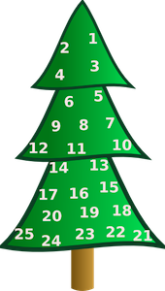

Before Christmas, many Christians use the time of [Advent](https://www.whychristmas.com/customs/advent.shtml) to prepare themselves and get ready to celebrate the joy of Christmas, when Christians celebrate of the birth of Jesus, who they believe is the Son of God.

Advent is normally a period of four Sundays and weeks before Christmas.

During Advent many people fast (don't eat certain foods). The types of food people give up depends on their church tradition and where in the world they live.

## After Christmas - The 12 Days of Christmas and Epiphany

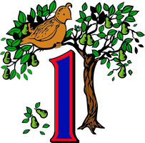

After Advent, traditionally, Christmas celebrations (and often a feast!) started on Christmas Day and lasted for 12 Days - so they were known as [The 12 Days of Christmas](https://www.whychristmas.com/customs/12daysofchristmas.shtml)! The celebrations finished on the evening of 5th January, which is better known as Twelfth Night.

Throughout history, the 12 Days of Christmas were a time of feasting and fun.

Following Twelfth Night, on 6th January, is [Epiphany](https://www.whychristmas.com/customs/epiphany.shtml), when people remember [the Wise Men (also sometimes called the Three Kings) who visited Jesus when he was a baby](https://www.whychristmas.com/story/wisemen.shtml); and the Baptism of Jesus when he was an adult.

Epiphany/Twelfth Night is also the time when it was traditional to take your Christmas decorations down - although some people leave them up until Candlemas.

## Candlemas - The End of Christmas

You might think that Christmas ends when you take the Christmas Decorations down - but it doesn't! After both Christmas and the season of [Epiphany](https://www.whychristmas.com/customs/epiphany.shtml), the end of the Christmas celebrations come on February 2nd, 40 days after Christmas, with Candlemas.

Candlemas, also known as the 'Presentation of Jesus at the Temple' or the 'Feast of the Purification of the Virgin (or Mary)' is the when some Christians remember the time [when Mary and Joseph took the baby Jesus to the Jewish Temple in Jerusalem to give thanks to God for giving them a son](https://www.whychristmas.com/story/newborn.shtml).

**Christmas Cake**

The rich fruit cake that is often associated with Christmas were originally Twelfth Cakes (which were eaten at the parties on [Twelfth Night ending the 12 Days of Christmas on 5th January](https://www.whychristmas.com/customs/12daysofchristmas.shtml#twelfthnight)).